



Attendance Policy

Version:1
Ratified by the Local Governing Body
Signed by the LGB |  | Date: 03.03.2026
To be reviewed every 2 years: |  | Date: 03.03.2028

Contents
1. Statement of intent 3
2. Legislation and guidance 3
3. Strategic Approach 4
4. Roles and responsibilities 8
5. Recording attendance 11
6. Authorised and unauthorised absence 16
7. School attendance, Safeguarding and Children Missing Education 17
8. Persistent absence 18
9. Term-time leave 19
10. Young carers 19
11. Rewarding good attendance 20
12. Monitoring and review 20
13. Changes 21
14. Appendix’s 22

- Statement of intent
To ensure that children receive their full entitlement to teaching and learning opportunities at Kitts Green Academy by promoting good attendance and punctuality.
Good consistent school attendance is regarded as essential in securing the desired outcomes for children and is crucial in ensuring that pupils have the best chance of success.
Kitts Green will give a high priority to conveying to parents, carers and pupils the importance of regular and punctual attendance. We recognise that parents and carers have a vital role to play and that there is a need to establish strong home-school links and communication systems that can be utilised whenever there are concerns about attendance.
If there are problems which affect a pupil’s attendance we will investigate, identify and strive in partnership with parents and pupils to resolve those problems as quickly and efficiently as possible, therefore, reducing the level of unauthorised absences.
Absence may be authorised by the school before or after it occurs. Unauthorised absence is when a pupil is absent and no explanation is provided by parents/carers or the explanation given is unacceptable to the school. The school will ensure that parents understand that it is their responsibility by law to make sure that their child attends school.
We are committed to meeting our obligations with regards to school attendance, including those laid out in the Department for Education’s (DfE’s) statutory guidance on working together to improve school attendance (19 August 2024), through our whole-school culture and ethos that values good attendance.

- Legislation and guidance
This policy is based on the Department for Education’s (DfE’s) statutory guidance on working together to improve school attendance (applies from 19 August 2024) and school attendance parental responsibility measures. The guidance is based on the following pieces of legislation, which set out the legal powers and duties that govern school attendance:
- Part 6 of the Education Act 1996
- Part 3 of the Education Act 2002
- Part 7 of the Education and Inspections Act 2006
- The Education (Pupil Registration) (England) Regulations 2006 (and 2010, 2011, 2013, and 2016 amendments)
- The School Attendance (Pupil Registration) (England) Regulations 2024
- The Education (Penalty Notices) (England) (Amendment) Regulations 2013 and the 2024 amendment
It also refers to:
- School census guidance
- Keeping Children Safe in Education
- Mental health issues affecting a pupil's attendance: guidance for schools

- Strategic Approach

  - Kitts Green Academy have adopted the Birmingham Education Partnership ‘5 Foundations of Effective Attendance Practice Framework’, which is modelled on the work of Professor Katherine Weare and positively reviewed by the DfE. The emphasis is on developing a school culture and climate which builds a sense of connectedness and belonging to ensure all children can attend school and thrive.
The approach ensures we prioritise building solid working relationships with children, and parents, prior to escalation. The staged approach we follow ensures we identify triggers early, that can lead to poor attendance issues, such as mental health issues, lack of trust, communication and relationship breakdowns and the possible lack of networking opportunities both internal (in-school) and external (external agencies).

  - Aims of the 5 Foundations strategy
• Increase school Attendance and reduce Persistent Absence to meet set targets.
• Ensure Attendance is well managed within the school, with the appropriate level of resources allocated.
• Enable the school to make informed use of attendance data to target interventions appropriately, focusing on the key demographic groups highlighted in the 2022 DFE attendance paper.
  - Objectives
- Create an ethos within the school in which good attendance is recognised as the norm and every child aims for excellent attendance.
- Make attendance and punctuality a priority.
- Set focused targets to improve individual attendance and whole school attendance levels.
- Embed the 5 Foundations of Effective Attendance Practice framework which defines agreed roles and responsibilities and promotes consistency in carrying out designated tasks with respect to promoting attendance and punctuality.
- Record and monitor attendance and absenteeism and apply appropriate strategies to minimise absenteeism.
- Develop a systematic approach to gathering and analysing relevant attendance data.
- Provide support, advice and guidance to; parents, children and develop mutual cooperation between home and the school in encouraging good attendance and in addressing identified attendance issues.
- Demonstrate, using rewards, that the school recognises good attendance and punctuality are achievements in themselves.

The main aim of the framework is to ensure the school promotes a culture of good attendance and celebrates success. Ultimately, the framework will ensure there is a culture of feeling safe and school being a place where children want to be.
Positive health and emotional well-being are key factors in improving social development, school attendance and educational achievement. The 5 Foundations of Effective Attendance Practice model promotes, and supports, a whole school approach to mental health and emotional well-being; ensuring SEMH support remains a key driver in improving attendance for all children.
Each Foundation is supported by 5 Key Performance Indicators, these are used to ensure the school can embed the Foundations framework and understand the strategic direction regarding attendance improvement. Each year the school will use the 5 Foundations self-assessment tool to understand what works well and identify what we need to do even better. We then follow the 5 Foundations school improvement process to implement the attendance plan and ultimately improve the lives of children and families we work with.

The school has a fully embedded ethos in which excellent school attendance is expected, developed and nurtured. The escalated approach to supporting attendance is built on foundations of belonging and connectedness.
The approach to improving attendance is built on clear policies, systems and processes. This ensures continuous and sustainable improvement drives attendance practice. The attendance policy is understood by all stakeholders and allows the school to set, and maintain, high expectations to improve the culture of attendance.

The school prioritises developing a team of attendance experts, with a shared vision and core purpose. The Attendance Leader delivers bespoke training to support all staff to fully understand their role in improving attendance. External partnerships support attendance improvements through a multi-disciplinary approach for identified children and families.
Data information and analysis direct resources proactively towards key demographic groups and identified individuals. The expert use of data analysis informs decision making at all levels. The attendance process ensures the Attendance Leader understands the reason for attendance concerns, these barriers can then be successfully supported and removed

Connecting and belonging drives the school approach to supporting attendance. All staff are supported to understand 'deeper roots' regarding poor attendance concerns. The school has developed, and embedded, an effective rewards system to further drive attendance improvements and celebrate success.

DFE: Working Together To Improve Attendance.
On the 19th August 2024, the DFE: Working Together to Improve Attendance guidance became statutory for schools. The table below identifies how the 5 Foundations of Effective Attendance Practice will underpin our delivery of the expectations set out in this statutory guidance.

- Roles and responsibilities
  - The Trust Board of Thrive Education Partnership has overall responsibility for the following areas but delegates the responsibility to the Local Governing Board of Kitts Green Academy:
- Setting high expectations of all school leaders, staff, pupils and parents
- Making sure school leaders fulfil expectations and statutory duties, including: Making sure the school records attendance accurately in the register, and shares the required information with the DfE and local authority
- Making sure the school works effectively with local partners to help remove barriers to attendance, and keeps them informed regarding specific pupils, where appropriate
- Recognising and promoting the importance of school attendance across the school’s policies and ethos
- Making sure the school’s attendance management processes are delivered effectively, and that consistent support is provided for pupils who need it most by prioritising staff and resources
- Making sure the school has high aspirations for all pupils, but adapts processes and support to pupils’ individual needs
- Regularly reviewing and challenging attendance data and helping school leaders focus improvement efforts on individual pupils or cohorts who need it most
- Working with school leaders to set goals or areas of focus for attendance and providing support and challenge
- Monitoring attendance figures for the whole school and repeatedly evaluating the effectiveness of the school’s processes and improvement efforts to make sure they are meeting pupils needs
- Where the school is struggling with attendance, working with school leaders to develop a comprehensive action plan to improve attendance
- Making sure all staff receive adequate training on attendance as part of the regular continued professional development offer, so that staff understand: The importance of good attendance
- That absence is almost always a symptom of wider issues
- The school’s legal requirements for keeping registers
- The school’s strategies and procedures for tracking, following up on and improving attendance, including working with partners and keeping them informed regarding specific pupils, where appropriate
- Making sure dedicated training is provided to staff with a specific attendance function in their role, including in interpreting and analysing attendance data
- Holding the headteacher to account for the implementation of this policy

  - The Headteacher is responsible for:
- The implementation of this policy at the school
- Monitoring school-level absence data and reporting it to governors
- Supporting staff with monitoring the attendance of individual pupils
- Monitoring the impact of any implemented attendance strategies
- Issuing fixed-penalty notices, where necessary, and authorising the Senior Leadership Team to be able to do so.
- Recognising the additional challenges faced by all pupils due to their Special Educational Needs and/or Disabilities (SEND) and working with the parents to develop specific support approaches for attendance including where school transport is regularly being missed, and where pupils face in-school barriers
- As all pupils at Kitts Green have an Education Health and Care Plan (EHCP), any pupil with falling attendance, particularly where there are barriers to school attendance that relate to the pupil’s needs, must be raised and discussed with the local authority.

- Communicating the school’s high expectations for attendance and punctuality regularly to pupils and parents through all available channels
  - Attendance Team (SLT, Family Support Worker and Senior Administrator) are responsible for:
- Leading, championing and improving attendance across the school
- Setting a clear vision for improving and maintaining good attendance
- Evaluating and monitoring expectations and processes
- Monitoring and analysing attendance data
- Regularly monitoring and evaluating progress in attendance
- Establishing and maintaining effective systems for tackling absence, and making sure they are followed by all staff
- Liaising with pupils, parents/carers and external agencies, where needed
- Building close and productive relationships with parents to discuss and tackle attendance issues
- Creating intervention or reintegration plans in partnership with pupils and their parents/carers
- Delivering targeted intervention and support to pupils and families
- Benchmarking attendance data to identify areas of focus for improvement
- Providing regular attendance reports to school staff.
- Working with the local authority to tackle persistent absence
- Advising the headteacher when fixed-penalty notices need to be issued
  - Administration Staff:
- Input attendance data via our MIS system
- Send daily reports to Attendance Team for monitoring purposes
- Managing the Pupil Signing in/out procedures.
- Make the first day absence calls and record reasons for absence
  - Class Staff, including teachers and support staff are responsible for:
- Providing a good example by always being punctual to registration and greeting children at the door – providing a welcoming environment;
- Keeping an accurate and up-to-date register of attendance, recording both morning and afternoon sessions on a daily basis.
- Following the Attendance Policy and ensuring pupils do so too. They are also responsible for ensuring this policy is implemented fairly and consistently.
  - Parents and Carers:
Where this policy refers to a parent, it refers to the adult the school and/or local authority decides is most appropriate to work with, including:
- All natural parents, whether they are married or not
- All those who have parental responsibility for a child or young person
- Those who have day-to-day responsibility for the child (i.e. lives with and looks after them)
Parents are expected to:
- Make sure their child attends every day on time
- Call the school to report their child’s absence before 8:30am on every day of the absence and advise when they are expected to return
- Provide the school with more than 1 emergency contact number for their child
- Ensure that, where possible, appointments for their child are made outside of the school day
- Keep to any attendance contracts that they make with the school and/or local authority
- Seek support, where necessary, for maintaining good attendance, by contacting the Assistant Head responsible for their child’s key stage.
- Recording attendance
5.1 We will keep an electronic attendance register on Bromcom and place all pupils onto this register.
We will take our attendance register at the start of each school day and at the start of the afternoon session. It will mark, using the appropriate national attendance and absence codes from the School Attendance (Pupil Registration) (England) Regulations 2024, whether every pupil is:
- Present
- Attending an approved off-site educational activity
- Absent
- Unable to attend due to exceptional circumstances
- Any amendment to the attendance register will include:
- The original entry
- The amended entry
- The reason for the amendment
- The date on which the amendment was made
- The name and position of the person who made the amendment
See DfE attendance codes below.
We will also record:
- Whether the absence is authorised or not
- The nature of the activity, where a pupil is attending an approved educational activity
- The nature of circumstances, where a pupil is unable to attend due to exceptional circumstances
- The following codes are taken from the DfE’s guidance on school attendance.

Code | Definition | Scenario
/ | Present (am) | Pupil is present at morning registration
\ | Present (pm) | Pupil is present at afternoon registration
L | Late arrival | Pupil arrives late before register has closed
Attending a place other than the school
K | Attending education provision arranged by the local authority | Pupil is attending a place other than a school at which they are registered, for educational provision arranged by the local authority
V | Attending an educational visit or trip | Pupil is on an educational visit/trip organised or approved by the school
P | Participating in a sporting activity | Pupil is participating in a supervised sporting activity approved by the school
Absent – leave of absence
C1 | Participating in a regulated performance or undertaking regulated employment abroad | Pupil is undertaking employment (paid or unpaid) during school hours, approved by the school
M | Medical/dental appointment | Pupil is at a medical or dental appointment
J1 | Interview | Pupil has an interview with a prospective employer/educational establishment
S | Study leave | Pupil has been granted leave of absence to study for a public examination
X | Not required to be in school | Pupil of non-compulsory school age is not required to attend
C2 | Part-time timetable | Pupil is not in school due to having a part-time timetable
C | Exceptional circumstances | Pupil has been granted a leave of absence due to exceptional circumstances
Absent – other authorised reasons
T | Parent travelling for occupational purposes | Pupil is a ‘mobile child’ who is travelling with their parent(s) who are travelling for occupational purposes
R | Religious observance | Pupil is taking part in a day of religious observance
I | Illness (not medical or dental appointment) | Pupil is unable to attend due to illness (either related to physical or mental health)
Absent – unable to attend school because of unavoidable cause
Q | Lack of access arrangements | Pupil is unable to attend school because the local authority has failed to make access arrangements to enable attendance at school
Y1 | Transport not available | Pupil is unable to attend because school is not within walking distance of their home and the transport normally provided is not available
Y2 | Widespread disruption to travel | Pupil is unable to attend because of widespread disruption to travel caused by a local, national or international emergency
Y3 | Part of school premises closed | Pupil is unable to attend because they cannot practicably be accommodated in the part of the premises that remains open
Y4 | Whole school site unexpectedly closed | Every pupil absent as the school is closed unexpectedly (e.g. due to adverse weather)
Y5 | Criminal justice detention | Pupil is unable to attend as they are:  - In police detention  - Remanded to youth detention, awaiting trial or sentencing, or  - Detained under a sentence of detention
Y6 | Public health guidance or law | Pupil’s travel to or attendance at the school would be prohibited under public health guidance or law
Y7 | Any other unavoidable cause | To be used where an unavoidable cause is not covered by the other codes
Absent – unauthorised absence
G | Holiday not granted by the school | Pupil is absent for the purpose of a holiday, not approved by the school
N | Reason for absence not yet established | Reason for absence has not been established before the register closes

We will keep every entry on the attendance register for 6 years after the date on which the entry was made.

  - Unplanned absence
The pupil’s parent must notify the school of the reason for the absence on the first day of an unplanned absence by 8:30, or as soon as practically possible, by contacting the school admin staff on 01215940890.
We will mark absence due to physical or mental illness as authorised, unless the school has a genuine concern about the authenticity of the illness.
Where the absence is longer than 5 days, or there are doubts about the authenticity of the illness, the school will ask for medical evidence, such as a doctor’s note, prescription, appointment card or other appropriate form of evidence. We will not ask for medical evidence unnecessarily.
If the school is not satisfied about the authenticity of the illness, the absence will be recorded as unauthorised and parents will be notified of this in advance.
  - Planned absence
Attending a medical or dental appointment will be counted as authorised as long as the pupil’s parent notifies the school in advance of the appointment.
Parents can request leave of absence by contacting the school admin staff on the above number.
We do, however, encourage parents to make medical and dental appointments out of school hours where possible. Where this is not possible, the pupil should be out of school for the minimum amount of time necessary.
The pupil’s parent must also apply for other types of term-time absence as far in advance as possible of the requested absence. Go to section 6 to find out which term-time absences the school can authorise.
  - Lateness and punctuality
A pupil who arrives late:
- Before the register has closed will be marked as late, using the appropriate code
- After the register has closed will be marked as absent, using the appropriate code
The school day begins at 9:00am. Pupils should transition from transport to their classroom at this time.
Registers are marked by 9:15am. Pupils will receive a late mark if they are not in their classroom by this time.
The register closes at 9:30am. Pupils will receive a mark of absence if they do not attend school before this time.
The afternoon session begins at 1.30pm. Pupils should be in their classroom at this time.
Registers in the afternoon are marked by 2.00pm. Pupils will receive a late mark if they are not in their classroom by this time.
Lateness for pupils on Local Authority arranged transport will be reviewed and recorded as Y as this is out of the control of the family and the school.
Pupils with 5 or more instances of lateness will begin to have their punctuality monitored more closely and parents will be informed of progress through the letters in appendices A – D.
  - Following up unexplained absence
Where any pupil we expect to attend school does not attend, or stops attending, without reason, we will:
- Call the pupil’s parent on the morning of the first day of unexplained absence to ascertain the reason. If we cannot reach any of the pupil’s emergency contacts, we may carry out a home visit to check on the pupil’s wellbeing and / or contact the pupils Social Worker (where relevant). If we carry out a home visit and are unable to make contact, we will contact the Social Worker (where relevant) or the Police.
- Identify whether the absence is approved or not
- Identify the correct attendance code to use and input it as soon as the reason for absence is ascertained – this will be no later than 5 working days after the session(s) for which the pupil was absent
- Call the parent on each day that the absence continues without explanation, to make sure proper safeguarding action is taken where necessary.
- If absence continues for three days, the school will arrange a wellbeing visit in person or on teams, in which we will ask to see the child, to check their physical wellbeing. Where the child has a Social Worker we may ask them to carry out this welfare visit. If we are unable to carry out a welfare visit and the child has not been seen by another professional, we will contact the police and ask them to make a welfare call.
- Where relevant, report the unexplained absence to the pupil’s youth offending team officer
- Where appropriate, offer support to the pupil and/or their parents to improve attendance
- Identify whether the pupil needs support from wider partners, as quickly as possible, and make the necessary referrals
- Where support is not appropriate, not successful, or not engaged with, we will progress through the Support First Attendance process and guidance put in place by BCC.
  - Reporting to parents
The school will regularly inform parents about their child’s attendance and absence levels via half termly letters, unless the level of absence has triggered a process (see the table in section 12, below), in which case contact will be made in line with this process.
- Authorised and unauthorised absence
  - Approval for term-time absence
The headteacher will allow pupils to be absent from the school site for certain educational activities, or to attend other schools or settings.
The headteacher will only grant a leave of absence to a pupil during term time if the request meets the specific circumstances set out in the 2024 school attendance regulations. These circumstances are:
- Taking part in a regulated performance, or regulated employment abroad
- Attending an interview
- Study leave
- A temporary, time-limited part-time timetable
- Exceptional circumstances
A leave of absence is granted at the headteacher’s discretion, including the length of time the pupil is authorised to be absent for.
We define ‘exceptional circumstances’ as an unexpected family incident that requires your child to be out of school or an absence related to the specific needs of your child.
Leave of absence will not be granted for a pupil to take part in protest activity during school hours.
As a leave of absence will only be granted in exceptional circumstances, it is unlikely a leave of absence will be granted for the purposes of a family holiday.
The school considers each application for term-time absence individually, taking into account the specific facts, circumstances and relevant background context behind the request.
Any request should be submitted as soon as it is anticipated and, where possible, at least two weeks before the absence, and in accordance with any leave of absence request form, accessible via the school office. The headteacher may require evidence to support any request for leave of absence.
Other valid reasons for authorised absence include (but are not limited to):
- Illness (including mental-health illness) and medical/dental appointments
- Religious observance – where the day is exclusively set apart for religious observance by the religious body to which the pupil’s parent belongs. If necessary, the school will seek advice from the parent’s religious body to confirm whether the day is set apart
- Parent(s) travelling for occupational purposes – this covers Roma, English and Welsh gypsies, Irish and Scottish travellers, showmen (fairground people) and circus people, bargees (occupational boat dwellers) and new travellers. Absence may be authorised only when a traveller family is known to be travelling for occupational purposes and has agreed this with the school, but it is not known whether the pupil is attending educational provision
- If the pupil is currently suspended or excluded from school (and no alternative provision has been made)
Other reasons the school may allow a pupil to be absent from the school site, which are not classified as absences, include (but are not limited to):
- Attending an offsite approved educational activity, sporting activity or visit or trip arranged by the school
- Attending another school at which the pupil is also registered (dual registration)
- Attending provision arranged by the local authority
- Attending work experience
- If there is any other unavoidable cause for the pupil not to attend school, such as disruption to travel caused by an emergency, a lack of access arrangements, or because the school premises are closed.
- School attendance, Safeguarding and Children Missing Education
- If a child goes missing from education it is a potential indicator of abuse or neglect. School staff will follow the Local Authority procedures for dealing with children that go missing from education. All Schools are required to make the local authority aware of every registered pupil who fails to attend school regularly and any children who have been absent from school, where the absence has been treated as unauthorised for a continuous period of not less than 5 school days, under the circumstances set out below. This attendance policy is part of broader suite of Safeguarding policies including the schools Safeguarding Policy and the Behaviour and Welfare Policy which support the wellbeing of our children. Regulations 8(f) and 8(h) of the Education (Pupil Registration) (England) Regulations 2006, as amended, place a duty on schools and local authorities to jointly carry out reasonable enquiries to try and locate pupils absent from school whose whereabouts are unknown.

This might be:
- A child who is not at their last known address and:
- has 5 or more days of continuous absence from school without explanation, or: -has left school suddenly and their destination is unknown.
- The family moving within the area but the parents fail to inform the school of the house move or transfer to a new school.
- The family move out of the area and relocate to a new area within the UK but parents fail to inform the school.
- The family relocate abroad and fail to inform the school of their destination.
- The family is displaced as a result of ‘crisis’ e.g. domestic violence, homelessness.
- Parent/school disagreement and parents withdraw the child from school.
- Family separation.
- Where a child cannot be accounted for
- Persistent absence
- If pupils are persistently absent (absence of more than 19 days), pupils will be raised with SLT and the Early Intervention Family Support Worker, who will review the situation surrounding the absences. Parents will be informed that their child has fallen below the threshold for persistent absence and a meeting might be arranged with the Head of Department.
- If necessary the Support First Attendance Framework will be implemented. Initially an Individual Action Plan will be completed and target set. Early Help support will be considered if appropriate.
- If all avenues have been exhausted and support is not improving attendance due to lack of engagement, the school will enforce attendance through statutory intervention or prosecution to protect the pupils right to education.
- Term-time leave
At Kitts Green Academy we require parents to observe the school holidays as prescribed.
The Headteacher is only allowed to grant a leave of absence in exceptional circumstances. Applications must be made in advance and the Headteacher must be satisfied by the evidence which is presented, before authorising term-time leave.
The Headteacher is unable to authorise holidays during term-time unless an explanation is provided, which outlines why it would more difficult to access the holiday in school holiday time, linked to the needs of the child. This would, therefore, count as exceptional circumstances.
The Headteacher will determine the amount of time a pupil can be away from school during term time. Any leave of absence is at the discretion of the Headteacher.
Requests for leave will not be granted in the following circumstances:
- Immediately before and during assessment periods
- When a pupil’s attendance record shows any unauthorised absence
- When a pupil’s attendance is below 95%

If parents take their child out of school during term-time without authorisation from the Headteacher, they may be subject to sanctions such as a penalty fine and the school will follow the Leave in Term Time (Legal) Process for Birmingham City Council. Unauthorised Leave in Term Time will be recorded as a G code in the register.
A Penalty Notice is an alternative to a prosecution. It requires the parent(s) to pay a fixed amount as a fine for their child's irregular attendance to avoid a court appearance. If the Penalty Notice has not been paid by Day 28, parents are generally prosecuted under section 444(1), the Education Act 1996. If this is necessary.
- Young carers
The school understands the difficulties that face young carers.
The school will endeavour to identify young carers at the earliest opportunity from enrolment at the school and throughout their time at the school.
The school takes a caring and flexible approach to the needs of young carers and each pupil will be examined on a case-by-case basis, involving other agencies if appropriate.
- Rewarding good attendance
SLT and staff liaise to agree systems, for both individuals and whole classes, to reward good and improved attendance.
In addition to these rewards, certificates are awarded for 100% attendance for each half term, term and for the whole year.
Reward systems will be reviewed regularly to ensure they are kept fresh and motivational. The school will look for every opportunity to raise the profile of the importance of good attendance with pupils and parents. The school also aims to help pupils develop their own motivation for daily, punctual attendance.
- Monitoring and review
The school’s office staff, on behalf of the school’s Headteacher, ensure all attendance data is accurately recorded and can authorise absence on the Bromcom attendance software. One member of staff is assigned this duty in the administrative team.
Attendance data is then checked daily by a member of the attendance team. An attendance report is produced and reported back to the Education Advisory Board (EAB) every half term.
Attendance data is monitored for:
- Pupils with 100% attendance.
- Any developing patterns of irregular attendance and lateness
- Pupils falling below 97% attendance more than 6 days of absence.
- Pupils who are persistently absent – any pupil whose attendance is below 90%
- Pupils with persistent lateness.
- Pupils with significantly improved attendance.
- Requests for holidays.
When any concerns for attendance are raised the school will aim to support pupils and their parents or carers to improve this through a number of measures. Kitts Green Academy operates a staged model of intervention to promote beneficial attendance.
In the first instance concerns about attendance are raised with parents and carers via letter and/or telephone call. Following this there will be opportunities for the parent/carer to discuss reasons for absence. In cases where attendance has not improved the school will identify a monitoring period and possibly a target to support improvement. Where this is not successful the school may then progress through the Support First Attendance procedures developed by Birmingham City Council’s Education Legal Intervention Team, to create an action plan to support parents/carers in raising attendance. Referrals may also result in legal action. Early Help may also be offered to parents and carers in cases where there are concerns surrounding attendance and/or punctuality.
Good attendance is further promoted by
- The application of schools’ Attendance Policy consistently.
- Training for relevant staff as necessary across the School.
- Creation and monitoring of regular attendance reports to SLT and relevant staff.
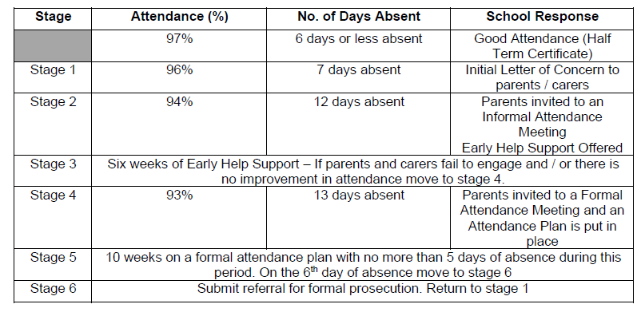
The table below highlights the attendance figures and response from the school in relation to the “Support First” attendance framework.

- Changes
Description | Date | Page | Section
New Policy

- Appendix’s
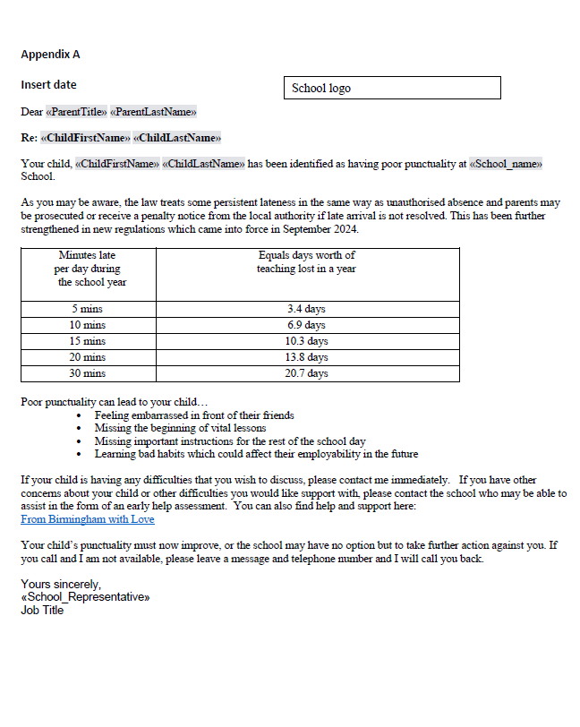

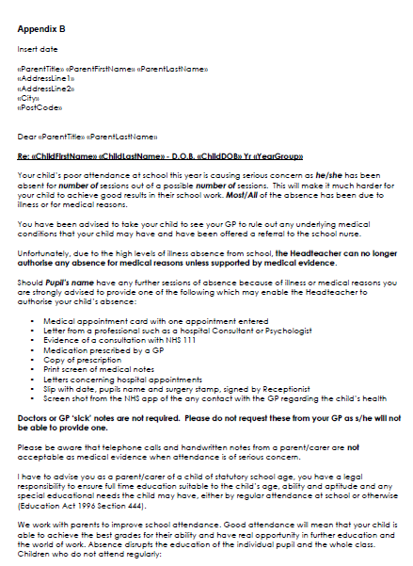

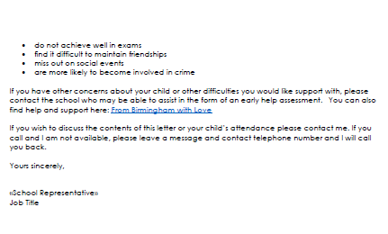
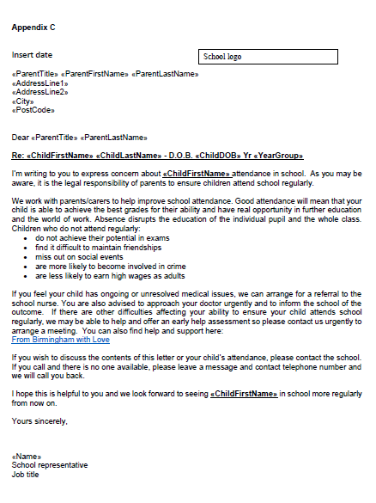

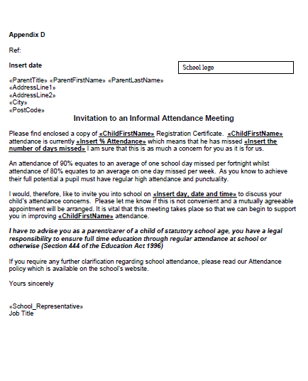

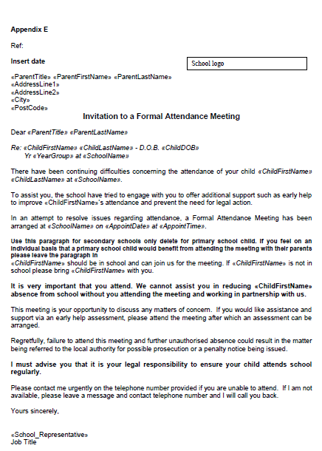
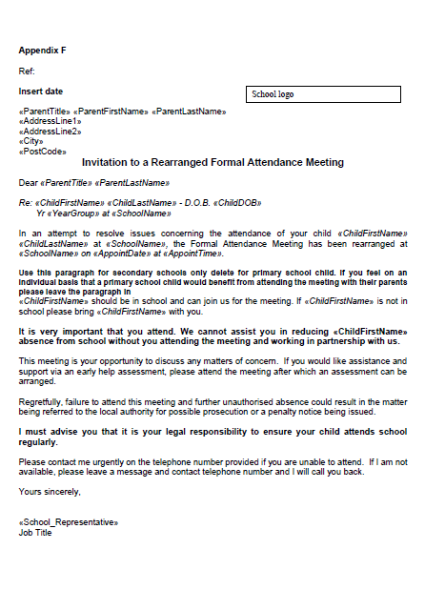

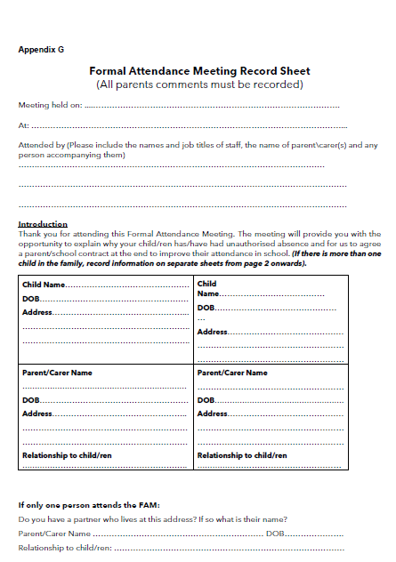

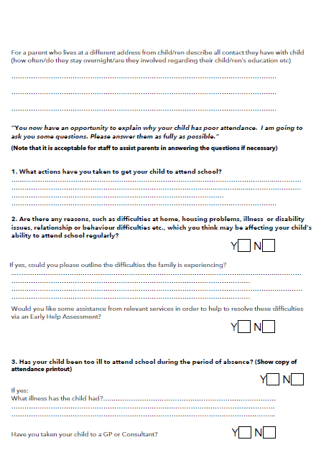

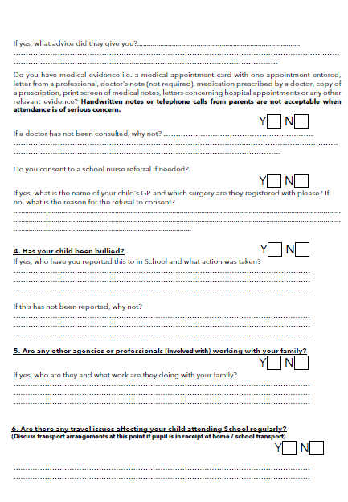

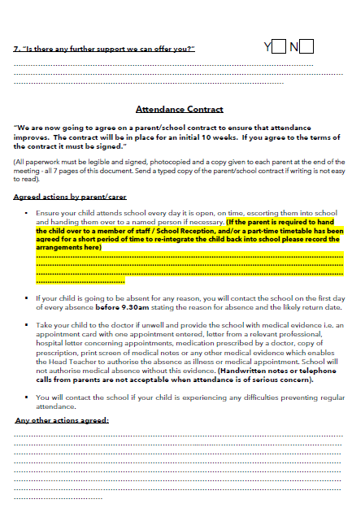

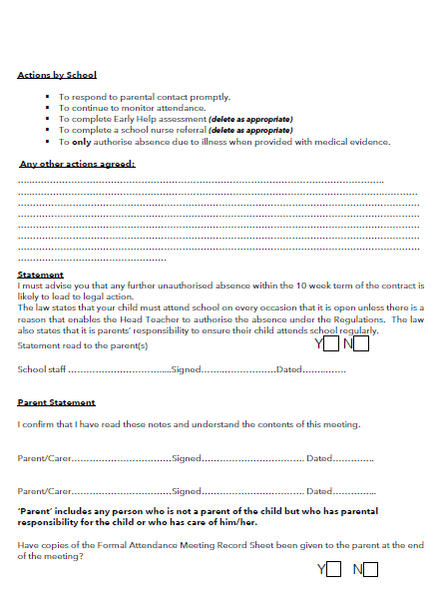

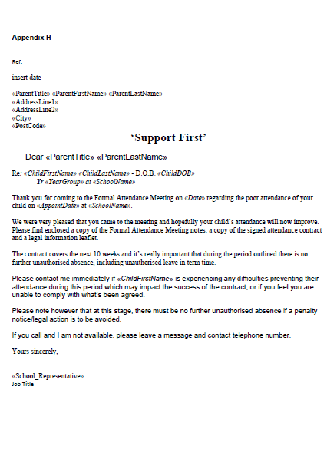

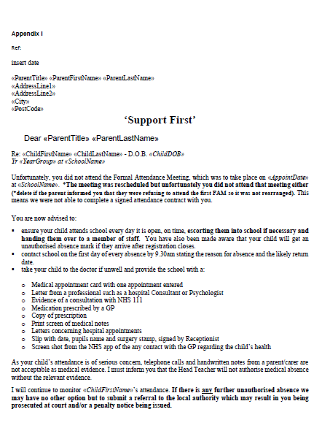

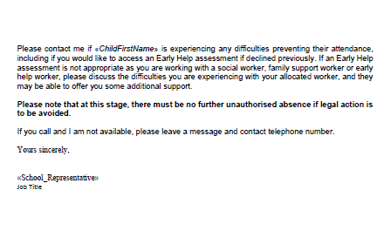

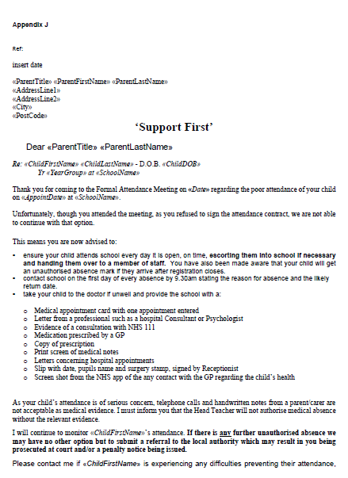
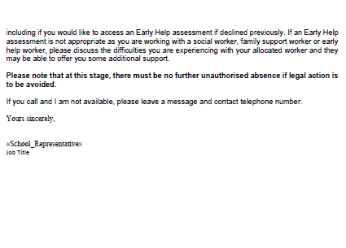
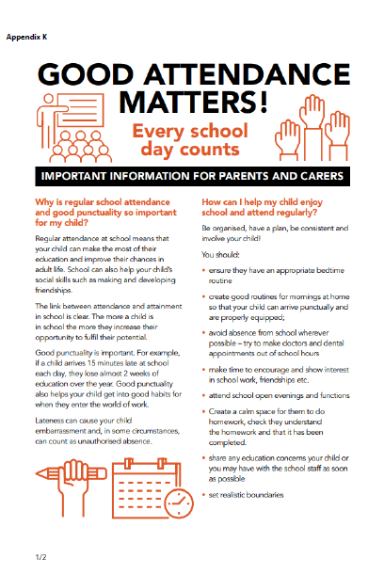



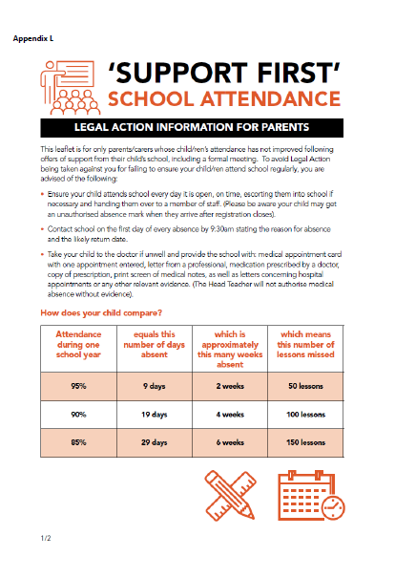

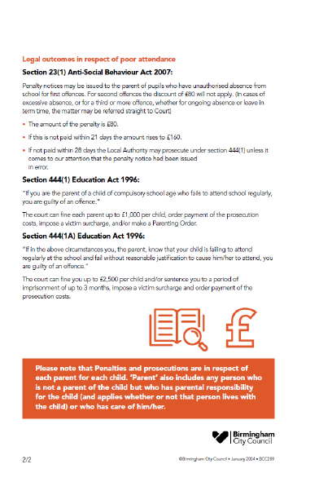

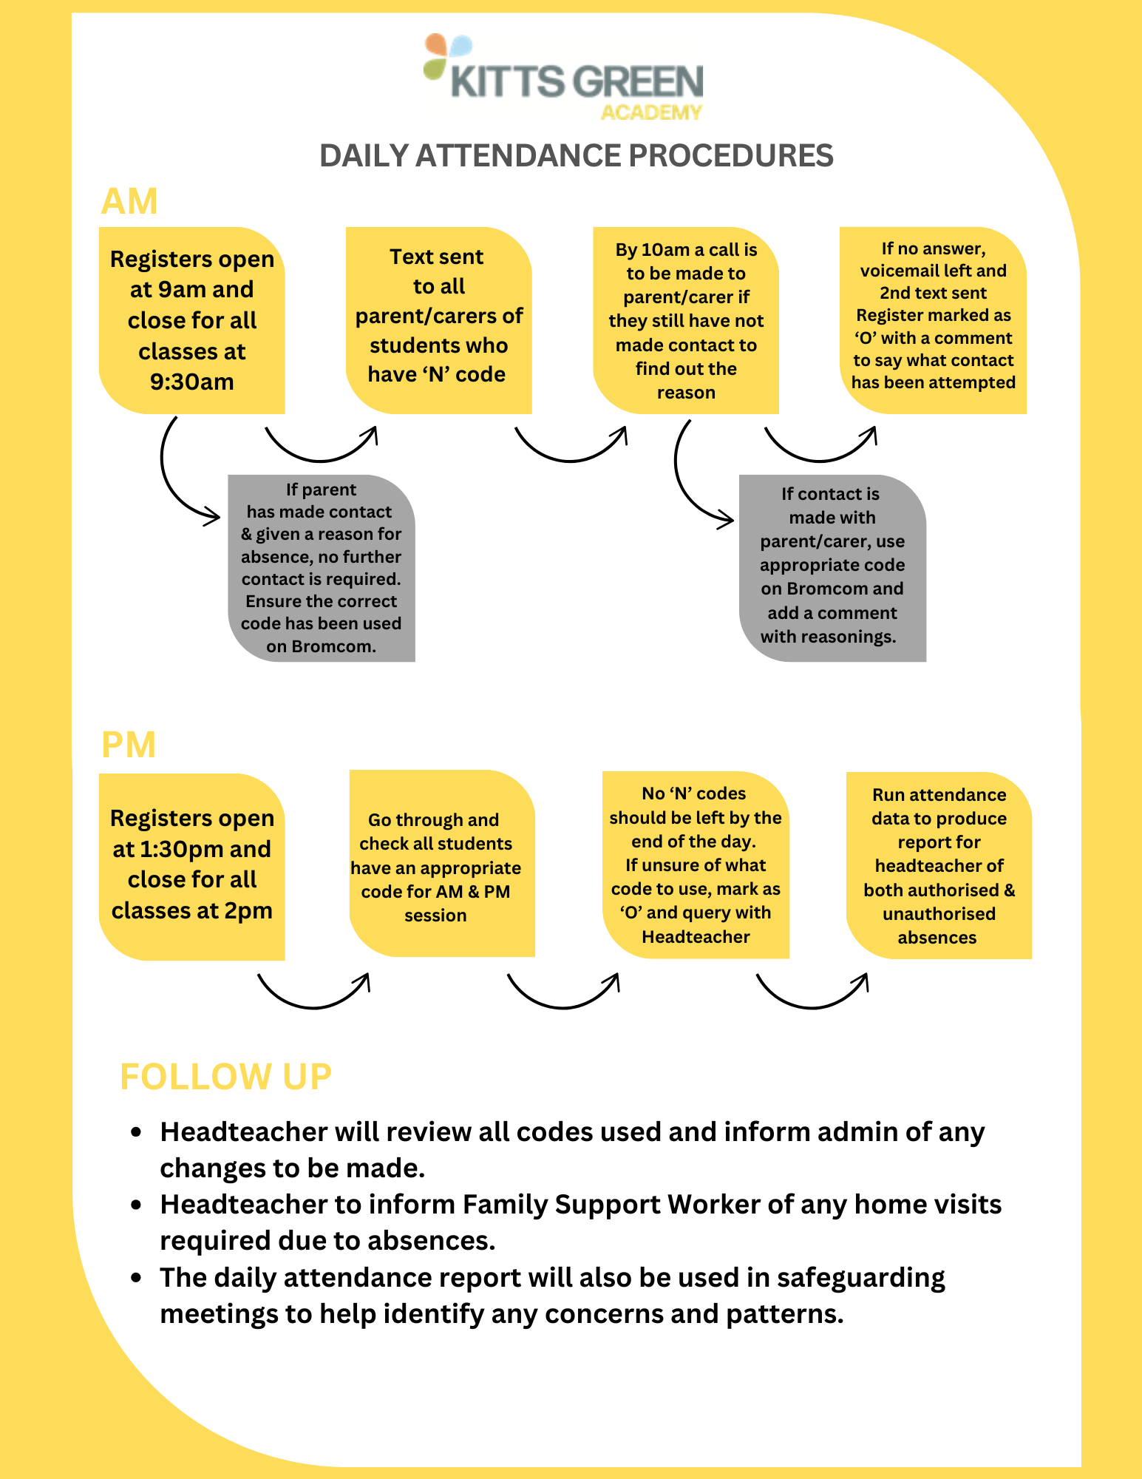
Appendix M

